INSTALLATION OF Nginx
NAME: SRIDHAR S
ROLL -NO: 23ISR055
Step 1: Installing Nginx Web Server
This step installs the Nginx web server on Ubuntu using the package manager.Nginx is used to serve web content and can act as a reverse proxy for applications like Jenkins.
Command to Run:
- sudo apt update
- sudo apt install nginx
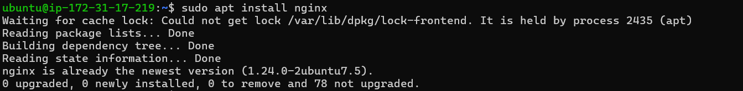

Step 2: Starting the Nginx Service
This step starts the Nginx service and enables it to run automatically on system boot.Ensuring the service is active allows web requests to be handled immediately.
Commands to Run:
- sudosystemctl start nginx

Step 3: Checking Nginx Service Status
This step verifies whether the Nginx service is running correctly.It helps confirm successful installation and service availability.
Command to Run:
- sudosystemctl status nginx

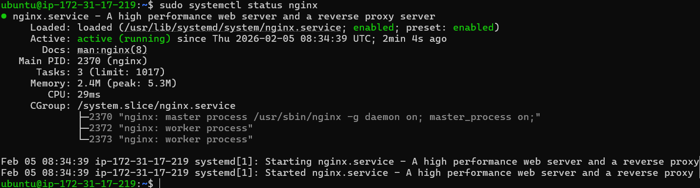

Step 4: Switching from Guest User to Root User
This step provides administrative privileges required to modify system-level directories and files.
Command to Run:
- sudosu
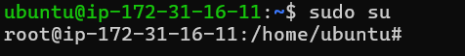

Step 5: Navigating to the Web Root Directory
This step moves to the default Nginx web content directory where HTML files are stored.The /var/www/html folder contains the default website files served by Nginx.
Command to Run:
- cd /var/www/html

Step 6: Opening and Editing the HTML File
This step opens the default HTML file in the Vim editor for modification.
Editing this file allows customization of the webpage content.
Command to Run:
- vim index.nginx-debian.html
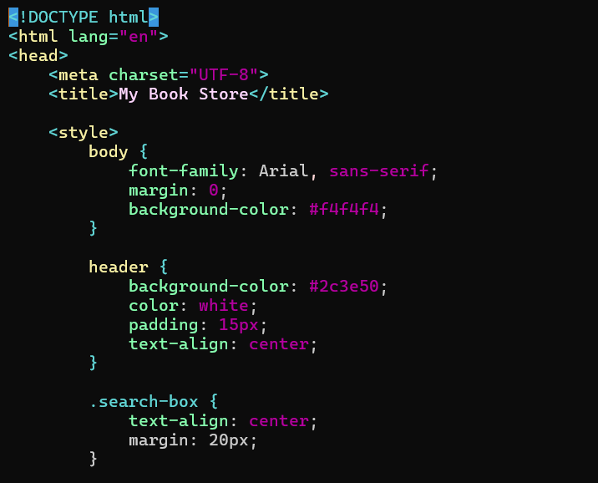

Step 7: Viewing the Edited File in Terminal
This step displays the updated HTML file content in the terminal.
It helps verify that the changes were saved successfully.
Command to Run:
- cat index.nginx-debian.html

Step 8: Accessing the Updated Webpage via Browser
This step verifies the changes by opening the server IP address and port in a browser.The updated HTML content should appear if configuration is correct.
Access Using:<server-ip>:80
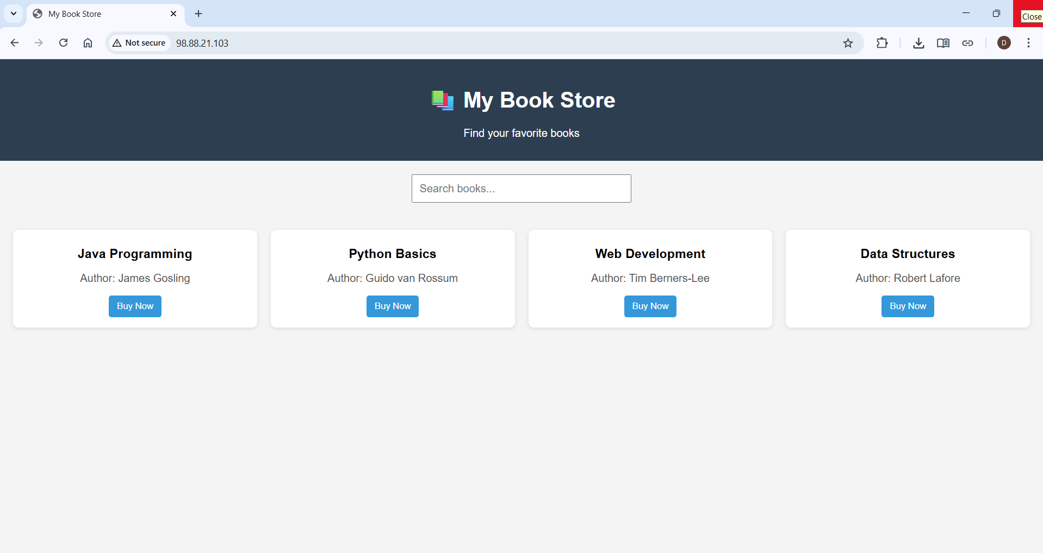

Step 9: Pulling the Nginx Docker Image,Running it and Checking its availability
It downloads the official Nginx image from Docker Hub to the local system by creating and starting a new Nginx container from the downloaded image.Atlastverify whether the Nginx container is running successfully
Commands to Run:
- docker pull nginx
- docker run -itd -p 90:80 nginx
- docker ps
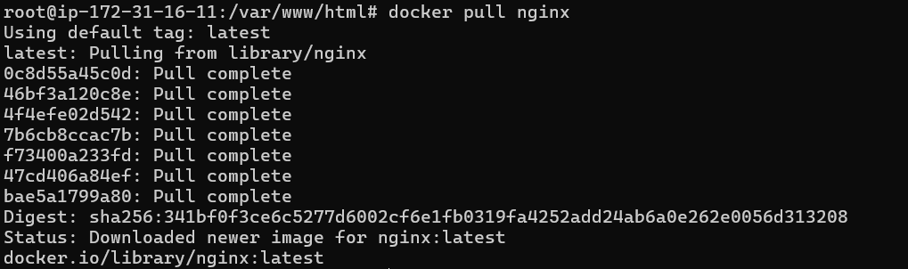

Step 10: Executing into the Running Container
This step opens an interactive terminal inside the running Nginx container.
It allows modification of files within the container environment.
Command to Run:
- docker exec -it (nginxid) bash

Step 11: Navigating to Nginx HTML Directory and Creating and Editing an HTML File
The /usr/share/nginx/html folder contains the website files served by Nginx.This step creates or modifies the default HTML file to display custom content.
Commands to Run:
- cd /usr/share/nginx
- cd html
- echo "(Content to view)" > index.html

Step 12: Accessing the Webpage in Browser
This step confirms the container is serving the updated HTML page.
Opening the mapped port in a browser displays the custom content.
Access Using:<server-ip>:90
